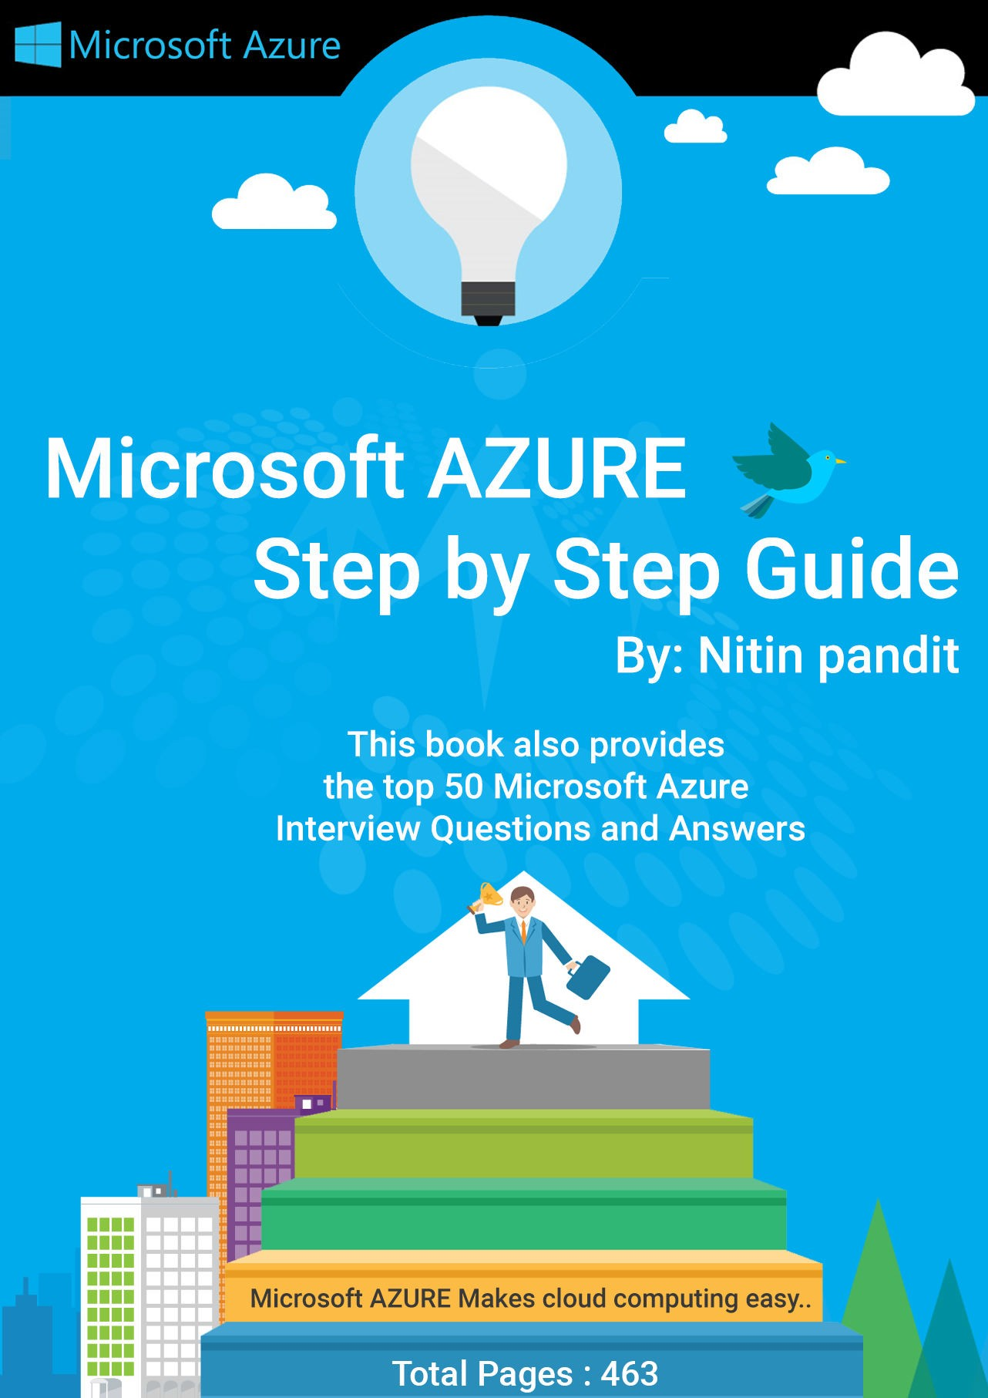

Microsoft Azure Step by Step

Guide

*This free book is provided by courtesy of* [*C# Corner*](http://www.c-sharpcorner.com/) *and Mindcracker Network and its authors. Feel free to share this book with your friends and co-workers. Please do not reproduce, republish, edit or copy this book.*

Nitin Pandit

Software Engineer, Microsoft.Net Consultant Noida C# corner Delhi Chapter Lead

C# corner MVP

Amit Mishra

(Co-Author, Format Editor)

|  |  |
| --- | --- |
| **Index** | **Page No** |
| **Chapter 1 - Getting Started With Microsoft Azure** | **1-17** |
| **Chapter 2 - How To Host Your Web Apps On Azure Via FileZilla** | **18-31** |
| **Chapter 3 - Configuring A Custom Domain Name For An Azure Website** | **32-40** |
| **Chapter 4 - Virtual Machine In Microsoft Azure Step by Step - Part One** | **41-50** |
| **Chapter 5 - Creating A Virtual Disk Virtual Machine In Microsoft Azure Step by Step: Part Two** | **51-66** |
| **Chapter 6 - Use of SQL Azure In Visual Studio 2015 Step By Step Guide** | **67-98** |
| **Chapter 7 - Entity Framework With Microsoft Azure SQL** | **99-113** |
| **Chapter 8 - Introducing U-SQL- Make Big Data Processing Easy** | **114-117** |
| **Chapter 9 - Installation Of Azure SDK And Blob Storage In Azure: Part 1** | **118-139** |
| **Chapter 10 - Upload Image To Azure Blob Storage In ASP.NET: Part 2** | **140-163** |
| **Chapter 11 - Demo Project Azure Blob Storage With ASP.NET MVC 5.0: Part 3** | **164-204** |
| **Chapter 12 - Getting Started With Azure DocumentDB: Day 1** | **205-224** |
| **Chapter 13 - Querying In The Azure DocumentDB: Day Two** | **225-242** |
| **Chapter 14 - Manage Azure Mobile Services: Part One** | **243-259** |
| **Chapter 15 - How To Create A Mobile App In Microsoft Azure** | **260-277** |
| **Chapter 16 - Manage Database Settings Of Azure Mobile Services** | **278-281** |
| **Chapter 17 - Get Twitter Account Connected Into Microsoft Azure Blob Storage Live** | **282-333** |
| **Chapter 18 - Cloud Services Scheduler In Microsoft Azure** | **334-339** |
| **Chapter 19 - Azure Media Services Overview And Playing Media** | **340-352** |
| **Chapter 20 - How To Use API Apps In Azure** | **353-362** |
| **Chapter 21 - Manage Data In Microsoft Azure Machine Learning** | **363-389** |
| **Chapter 22 - Working With Azure RemoteApp** | **390-402** |
| **Chapter 23 - Microsoft Azure Service Bus** | **403-417** |

**Chapter 24 - Top Interview Questions and Answers Of Cloud Computing And Microsoft Azure**

**418-465**

**About Author**

He is a Microsoft Professional having Master's degree in Computer Science. With over 5 years of experience his rick skill set includes designing, integrating, implementing, ORM with LINQ, WCF, MVC & managing IT/Web applications. He is an expert in C#.NET ADO.NET, LINQ to SQL, LINQ to EF, ASP.NET 2.0/3x/4.0, WCF, MVC 5.0

(Razor), WPF and Silverlight, including client side technologies jQuery and AngularJS.

He has trained more than one lakh students and professionals as a speaker for workshops and AppFests conducted in more than 25 universities of North India.



**Nitin Pandit**

Software Engineer, Microsoft.Net Consultant Noida **C# corner Delhi Chapter Lead**

## C# corner MVP

1

Firstly[, go to http://Azure.microsoft.com/](http://azure.microsoft.com/) and create a free Microsoft Azure Account.

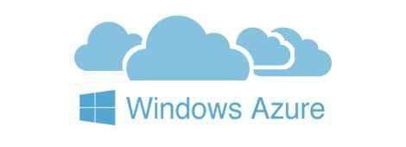

**Getting Started With Microsoft Azure**

I am going to start a new article for users who want to learn Microsoft Azure from the scratch.

Let's start with a step by step approach.

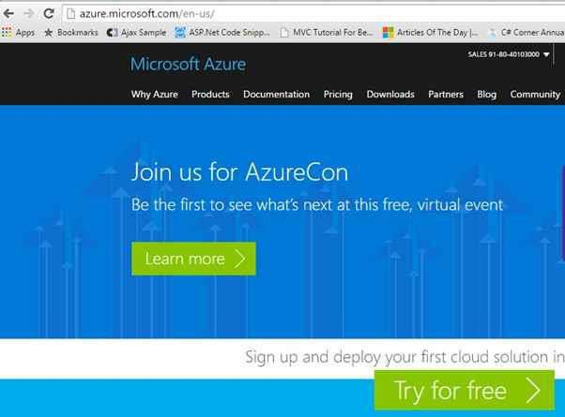

2

Now you can manage your Azure portal from web account or directly from your Visual Studio using Azure SDK. If you are using VS2012, down[load Azure SDK](http://azure.microsoft.com/en-in/downloads/) first.

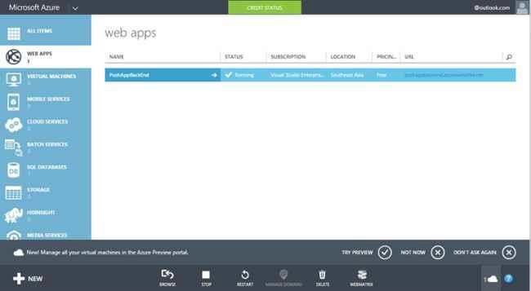

When you *log in* Microsoft Azure with any Microsoft Account like Outlook, Live or other, you will get an Account. After that go to [https://manage.windowsAzure.com/](https://manage.windowsazure.com/) and login, then click on portal link.

You can see the image in the following portal.

And after installing Azure SDK, your Visual Studio Server Explorer will be visible.

3

Right Click on SDK and click ―**Connect to Microsoft Azure Subscription**‖.

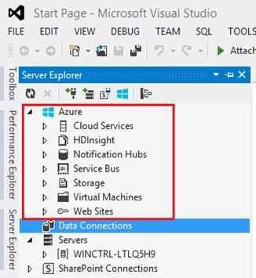

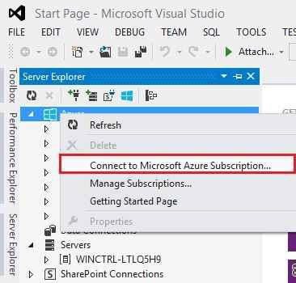”

4

Enter your Microsoft Account Id on which you have Azure Subscription, then password details and press enter to login.

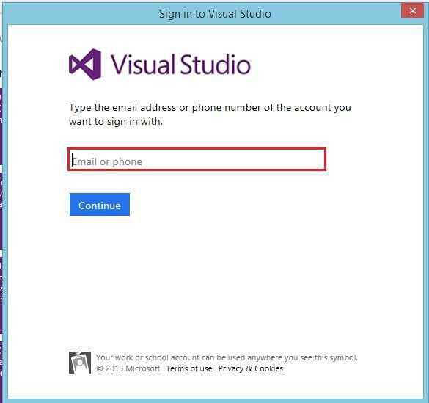

It will open a window to log in Microsoft Azure Account.

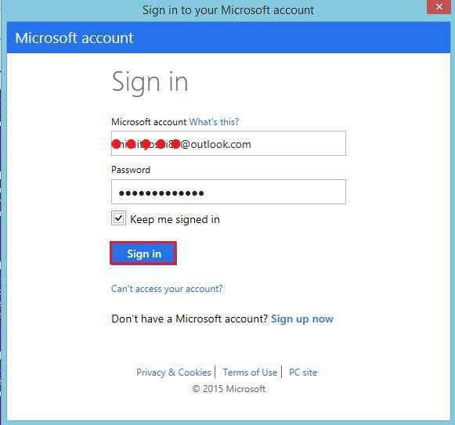

5

If you need to add or create a new website in your Azure Account, we have the following two ways:

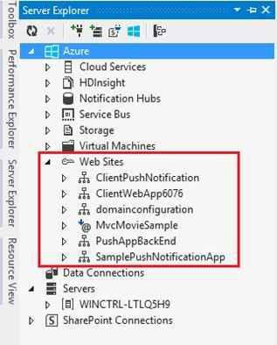

Now go to Azure SDK in Visual Studio Server Explorer and open *Web Sites.* Now you can see all the web sites created in your Azure Account.

1. By Microsoft Azure SDK in Visual Studio.
2. By Microsoft Azure Web Portal.

So let’s see both one by one and step by step.

6

Now you’ll see a window where you have to enter the following details:

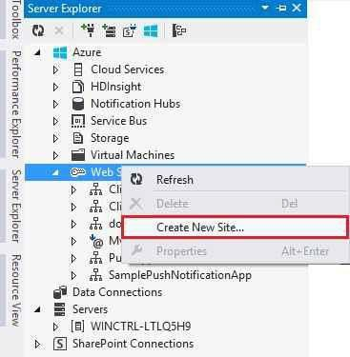

**By Microsoft Azure SDK in Visual Studio:**

**Step -** Go to *Azure* SDK in *Server Explorer* and right click on *Web Sites* and find the link

―**Create New Site**‖.

1. Site Name.
2. Select Region.
3. Database Server (if you have).

7

Let say I have entered my new site name ―**meandmy**‖, if the name is available it will allow me to create web site. Select a region like I selected East Asia. At last select database if you have any database on Azure for your web site.

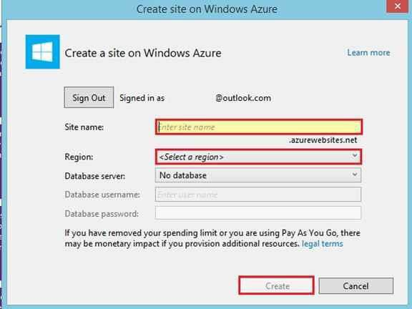

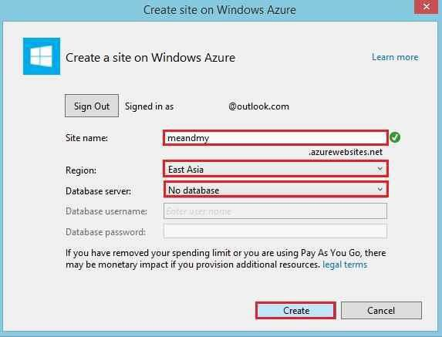

8

Now go to your Azure portal and refresh. After refreshing it, you can see the same site in your web portal created by SDK.

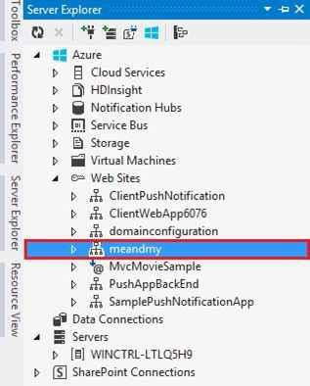

When you click on create button, you can see your web site to SDK or Azure web portal.

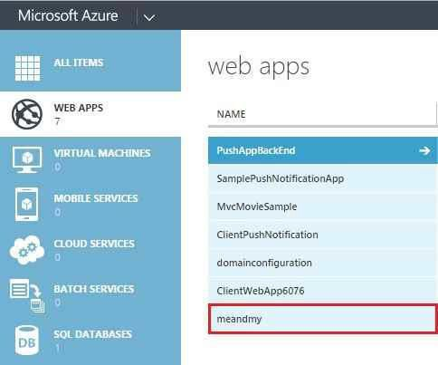



**By Microsoft Azure Web Portal**

Now I am going to create web site from Web Portal, so let’s go to web portal and see the NEW

button on the left side bottom and click on it.

9

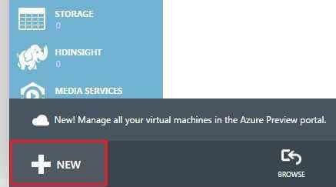

Now click *COMPUTE*, then *WEB APP* and *QUICK CREATE*:

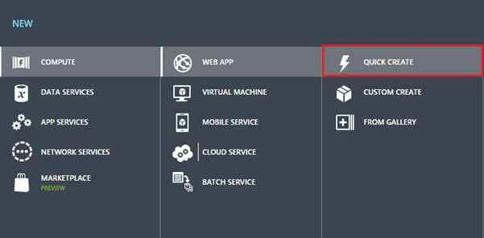

10

After that enter all the details,

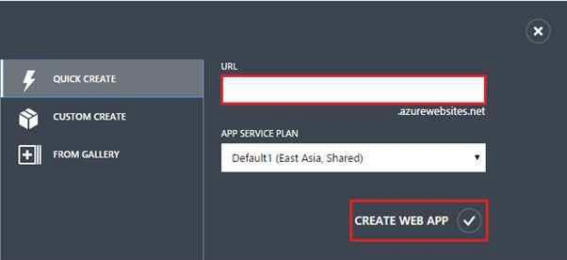

Now enter a URL for Website on which you need to host you web site and select *APP SERVICE PLAN* and lastly click *CREATE WEB APP*:

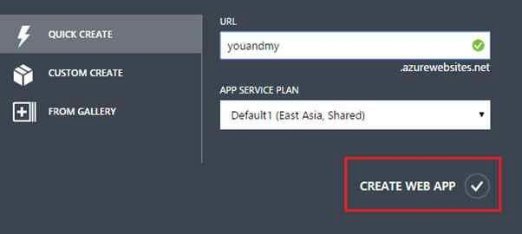

11

If you want to use this in SDK, open SDK and right click on *Refresh*.

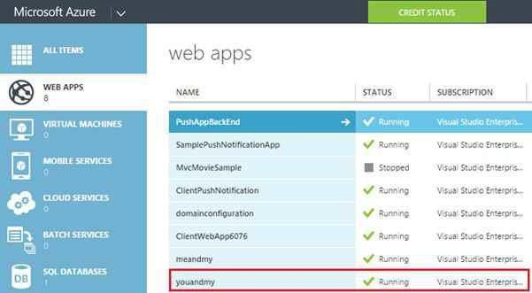

Now web site is ready to use.

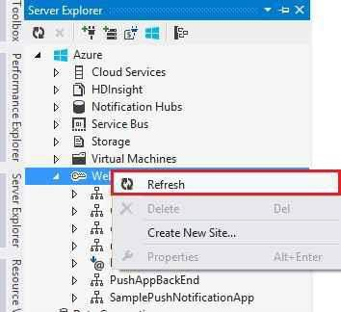

12

Create Web Project in Visual Studio to host on Web site that is already created on Azure Account. Open Visual Studio, *File*, and then *New Project* and select *Web*. After that click ASP.NET Empty Web Application and press *OK*.

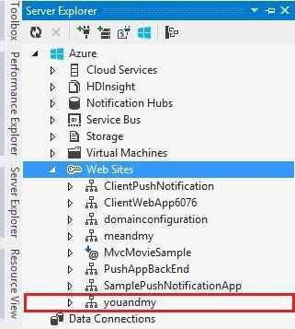

Now you can see the websites on SDK.

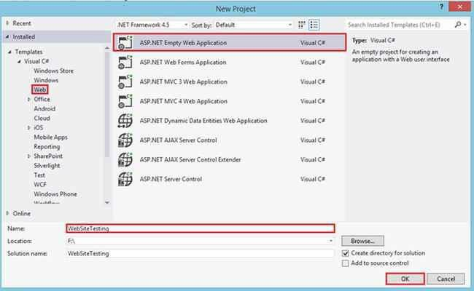

13

Write any name for view page.

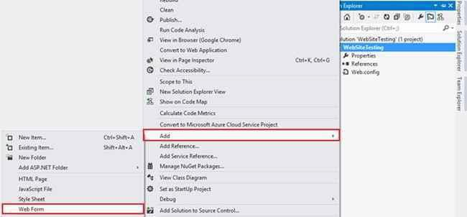

Open Solution Explorer now and right click on Project, then add any Default page to View the Test Output.

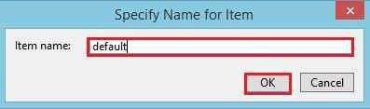

I just wrote a welcome message on page for testing.

14

If I run this web application on local system, the output will be the following:

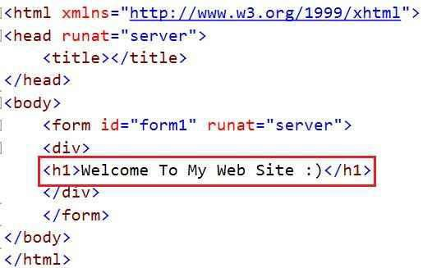

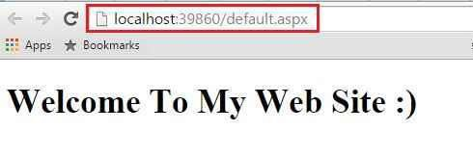

Now I will upload this to web site in Azure.

Firstly, right click on the project and find the link *Publish*...

15

Select the publish target select type and if you want to publish on Microsoft Azure, select the first link in the following window and click *Publish* button.

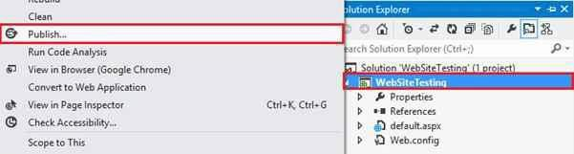

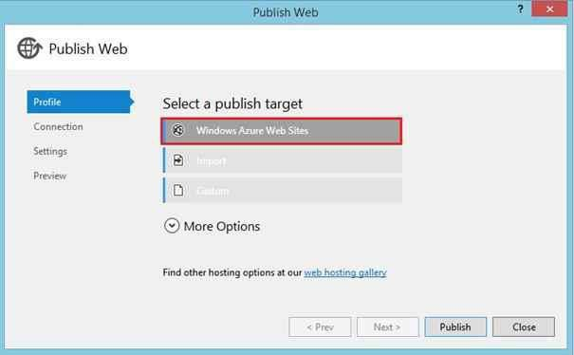

Now select your website name from the dropdown where you need to upload.

16

After selecting the website, it will download all the publish profiles from Azure and will fill all the details.

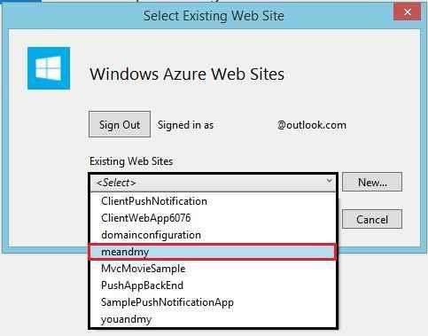

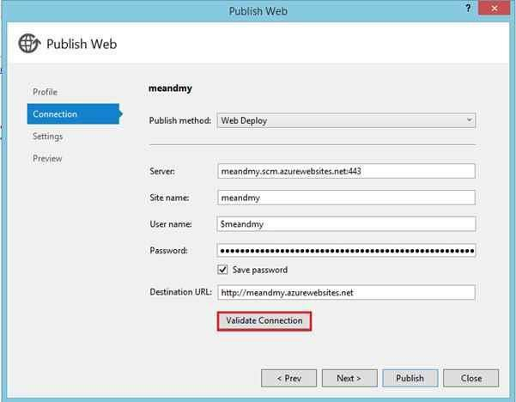

Click on *Validate Connection* button to check all the settings are valid or not. If all are valid, click*Publish* Button.

17

Now see the upload progress in output window.

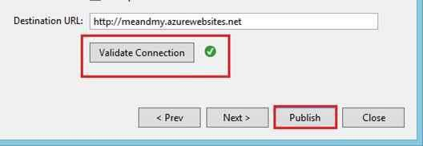

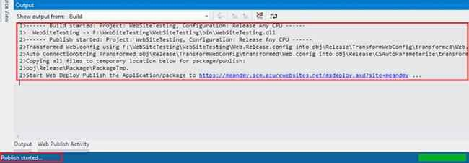

After *Publish* succeeds it will directly open the URL in the Web Browser. Now you can check this link anywhere or any device like mobile.

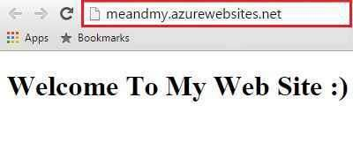

18

For creating a new Web App you must login into Azure.



**How to Host Your Web Apps on Azure via FileZilla**

In this chapter, I’m going to upload a website to the Microsoft [Azure](http://www.c-sharpcorner.com/technologies/azure) via FileZilla (FTP).

FileZilla is a cross platform FTP application which is totally free software. We’ll create a Web

App then download and publish profile of that Web App.

Go to *WEB APPS*, and select ―*NEW*‖ button at the bottom of the window.

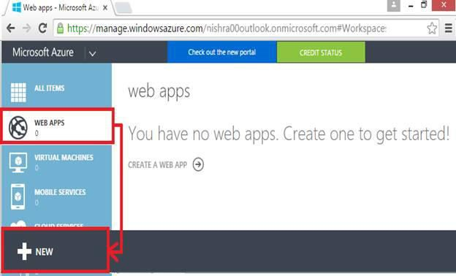

Go to *COMPUTE, WEB APP, And QUICK CREATE*.

* Enter the name of your Web App.
* Enter your subscription.
* Select region/location of your Web App.
* Click on to ―*CREATE WEB APP”*.

19

Wait for few seconds to complete processing, your WebApp is created and in running mode.

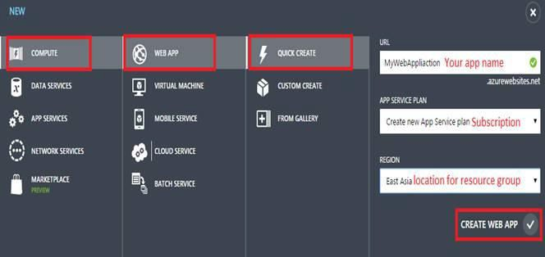

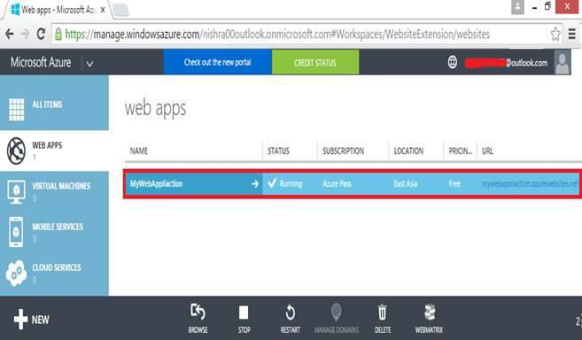

After creating our Web App on Azure, you can start with Visual Studio, write some text in to HTML page and that text will show in browser. We’ll see how we can publish our website to Azure without Visual Studio.

20

So, now our Web App and HTML text are completed, go back to your Web App.

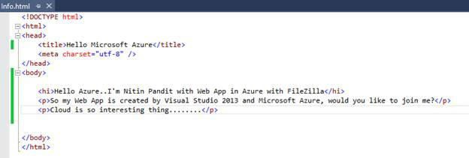

So, create a simple application from Visual Studio and make some HTML text in to HTML page. Here's the screenshot,

Click on to your Existing Web App and select ―*DASHBOARD*‖ to download the publish profile of your Web App.

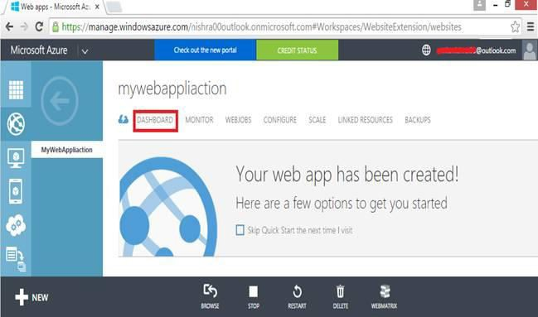

In dashboard panel, click on to ―*Download the Publish Profile*‖.

21

Right click on the downloadable file and open it with *Notepad* to collect all the FTP information.

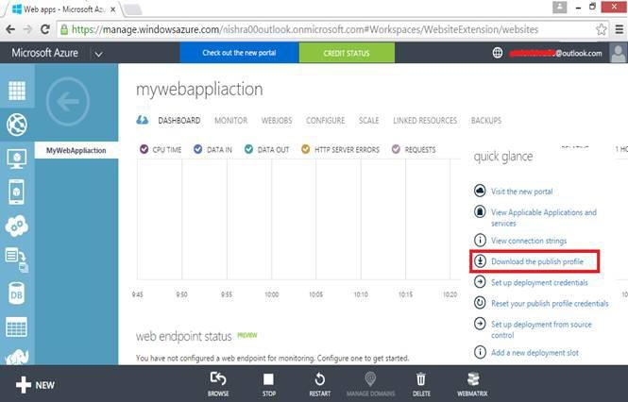

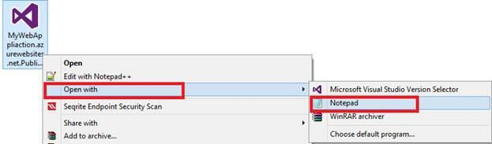

In the following screenshot, you will get publishUrl (which is your host name), username and user password.

22

Now you will need to download FileZilla software from its official website. For more you can see the following screenshot,

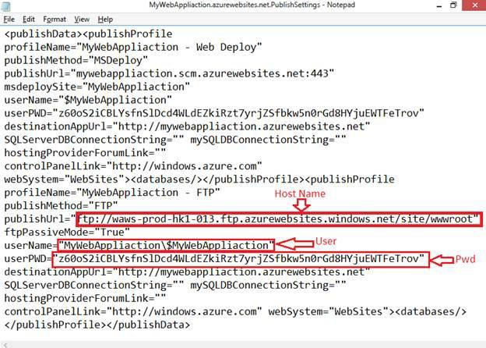

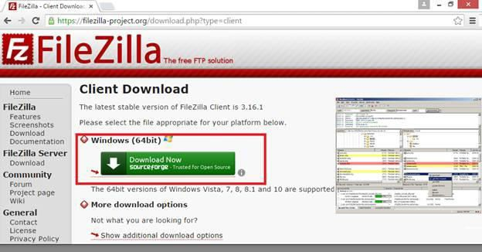

23

This will ask for administration of FileZilla whether you want for *Anyone* or only for you, so

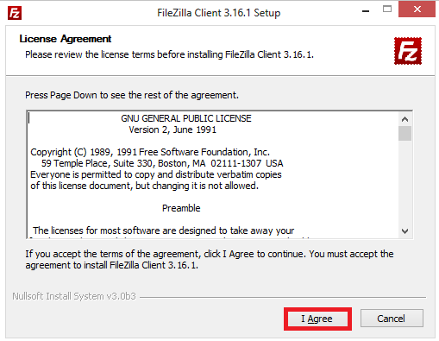

Accept the terms of license agreement by clicking on ―*I Agree*‖.

here I’m selecting all users, click on to next button.

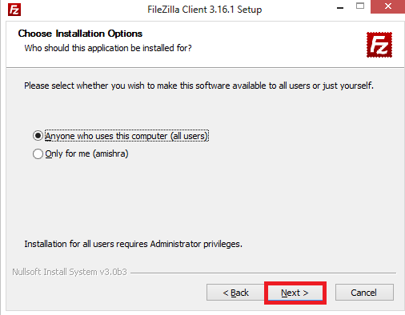

24

Select the path of installation, and click on the next button.

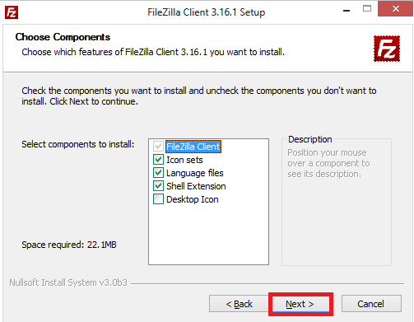

Next step of setup is selecting components of FileZilla which you want to install, so mark all the components and click on the next button.

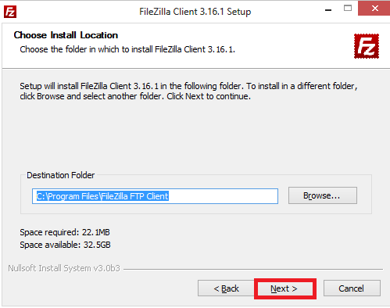

25

Your setup is being installed.

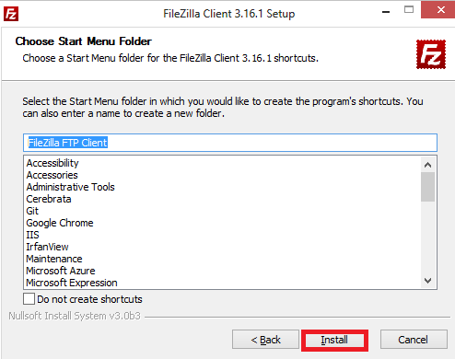

The following screenshot is asking for start menu and if you do not want to create a shortcut then check on "*Do not create shortcut"*, and click on ―*Install*‖ button.

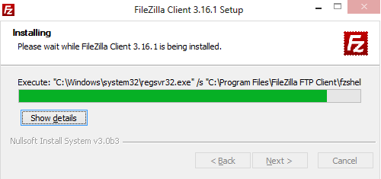

Click on to finish button to complete the process of setup.

26

In *File* menu select ―*Site Manager*‖.

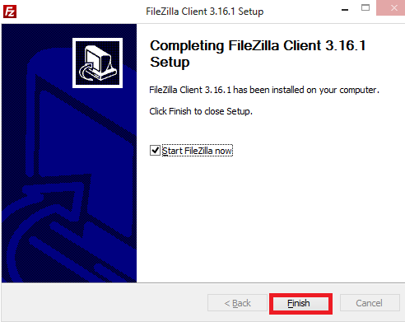

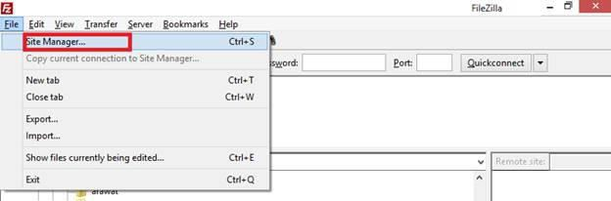

Under the site manager, click on to ―*New Site*‖.

27

Give a name to your new site.

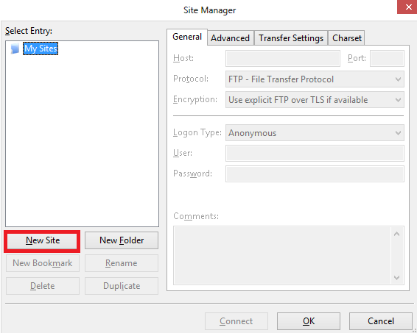

Under the *General* tab in the right side give the following values according to the following screenshot,

**Host:** Paste the hostname from publishUrl obtained from the published settings file above in Notepad.

**Logon Type:** Set this to Normal.

**User**: Paste the userName obtained from the publish settings file above in Notepad.

**Password**: Paste the userPWD obtained from the publish settings file above in Notepad. Click on *Connect* to connect to the site over FTP.

You will see two folders under the root: Logfiles and Site.

28

Or you can follow the following procedure,

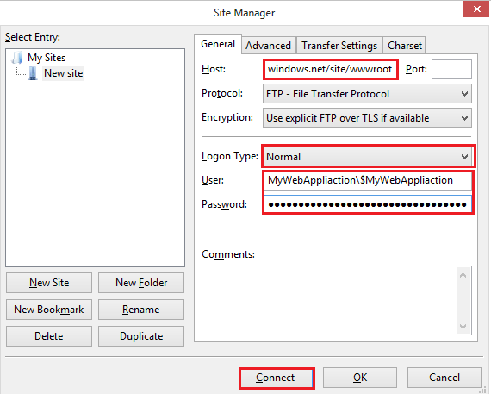

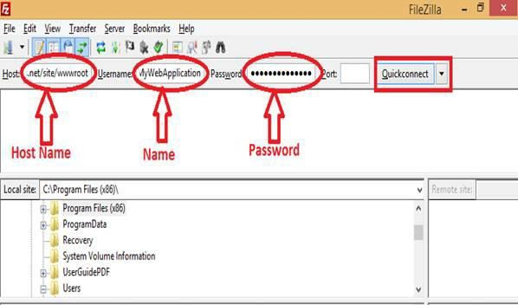

After connecting to the server your status will be successful and *wwwroot* folder will get created in directory.

29

Now go to your Visual Studio project and select all the files of project, by clicking right, upload it.

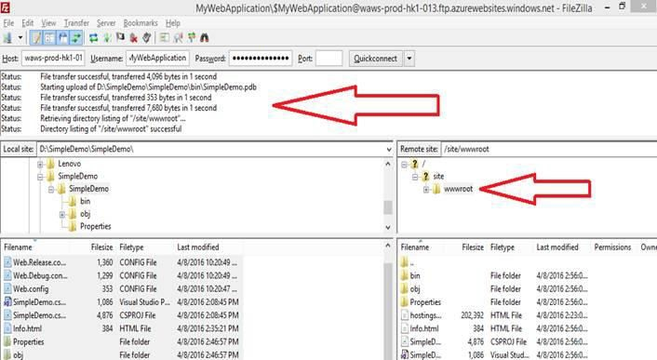

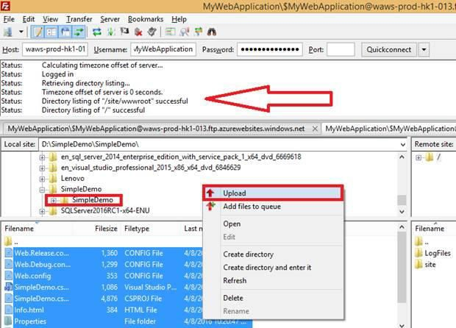

30

If everything is completed successfully then go back to your Web App and click on it.

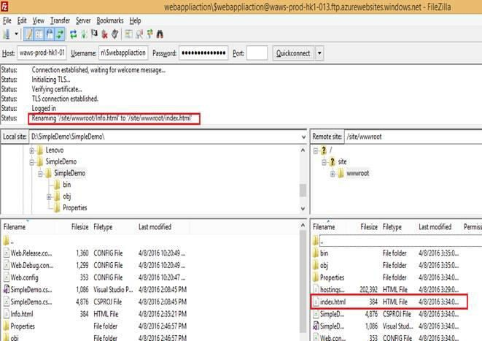

So, we created an html file with ―info‖ named in my Visual Studio, change the name of file

info.html to index.html. For more see the following screenshot.

We have a connection with the FTP Server on Azure Cloud and on our local PC.

31

So here I got my result, I have successfully deployed our HTML page. We can publish our website to Azure without Visual Studio.

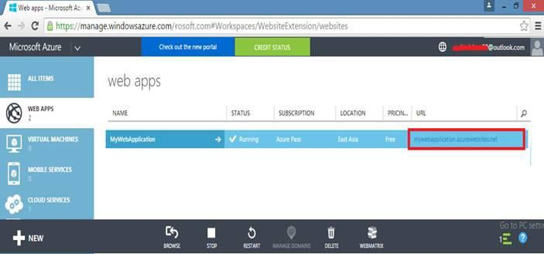

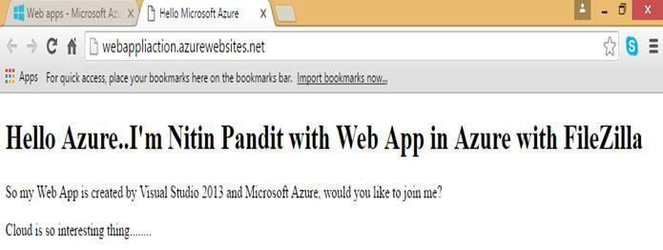

I hope you enjoyed this chapter.

# Configuring a Custom Domain Name for an Azure Website



32

A domain name is a URL which is responsible to access websites. Domain name identifies IP address. Domain name is an identification string which defines a scope of administrative autonomy, control within Internet. Any domain name locates Internet address for an URL at points to Internet and particular host server named.

For managing our custom domain name, you must have to login with [Azure](http://www.c-sharpcorner.com/technologies/azure).

Firstly, we need to create a Web App, so go to Web Apps blade and click on ―New‖ button in the

bottom of the page.

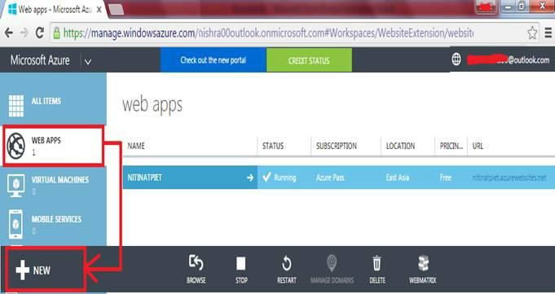

In compute section creates a Web App.

Give a name to your Web App; here I have given it ―customdomainweb‖.

33

Web App will be successfully created, click on it for further.

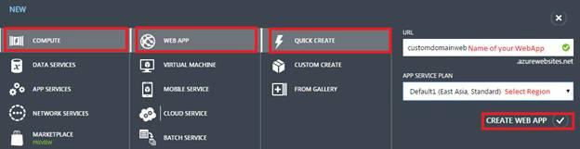

Select your Service Plan whether you want the location of your Web App and then click on to

―*CREATE WEB APP*‖.

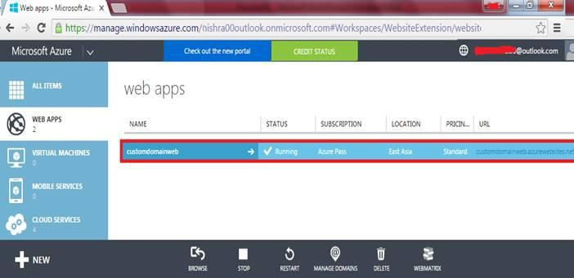

Click on ―*SCALE*‖ panel to select the mode for your Web App.

34

In the following screenshot, for custom domain name we need to select app service plan pricing tier which is available in Shared, Basic and Standard modes for the Web App. Select *Shared* plan and save it.

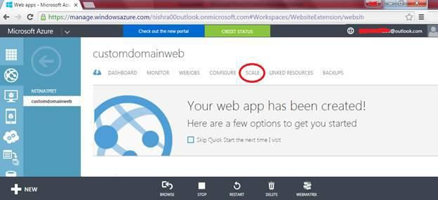

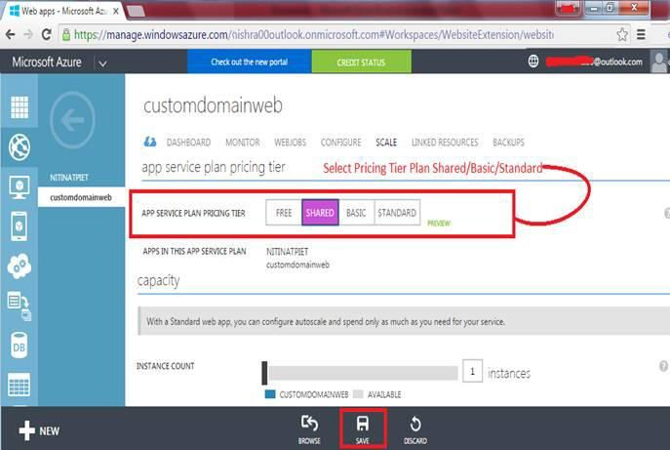

35

So, my Web App has a domain and virtual IP Address, we need to map this IP Address to the specific domain which we can buy from the Godaddy website.

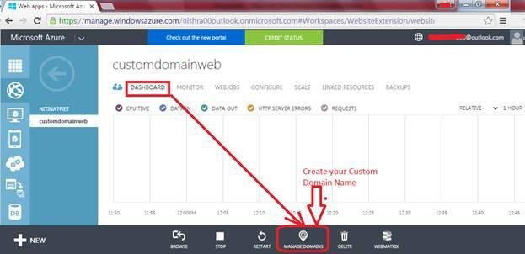

Click on to ―*Dashboard*‖ to manage custom domain, in the bottom of the window hit on

―Manage Domains‖.

Put your domain name which you want to set, when you want to put your domain name it will mark as red because we do not map with specific domain name.

Here also we can see the IP Address and CNAME (Canonical Name) to map our particluar website to specific domain name.

36

Log into your domain provider, here, I’m using Godaddy account, and go to ―DNS Zone File‖

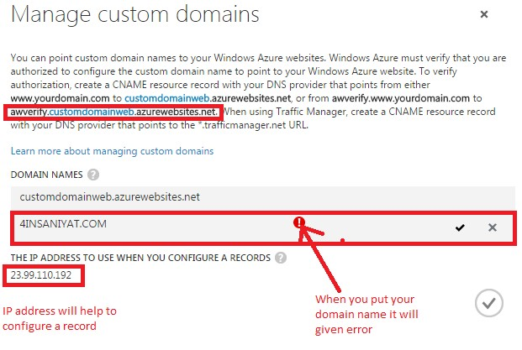

panel to make some changes.

We need to add a record of Host, click on to ―*Add Record*‖.

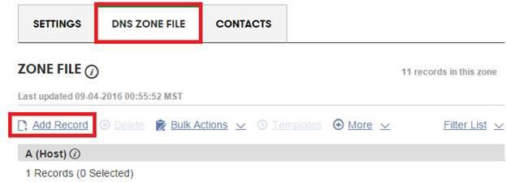

37

**Points To:** Enter IP Address of your Web App. According to your choice give Time to Live to it. Click on to finish button to add this record.



A record, maps a domain name to an IP Address means *customdomainweb.com* mapped to my IP.

**Record Type:** Record Type would be A(Host) from the dropdown menu.

**Host:** In the Host panel give to @ symbol.

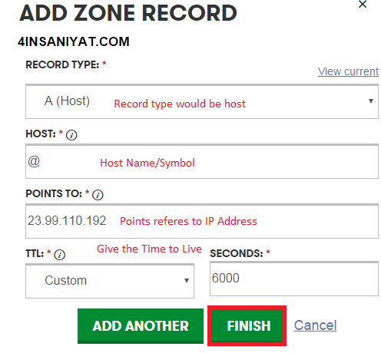

38

Now we need to add CNAME, which maps a domain name to another domain name means

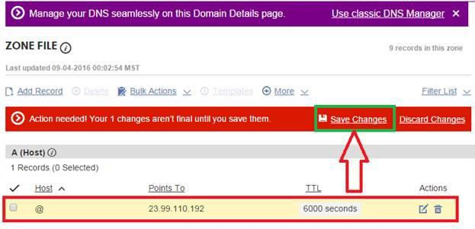

A record will be created, for saving the change click on to *Save Changes*.

[*www.customdomainweb.com*](http://www.customdomainweb.com/)mapped to *customdomainweb.Azurewebsites.net*.

To create a CNAME click on to ―Add Record‖.

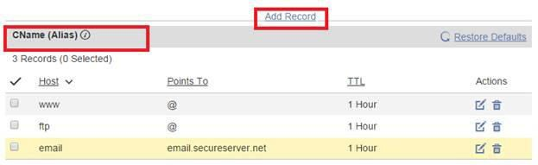

Choose the CNAME from the dropdown menu.

39

Add another CNAME points to map.

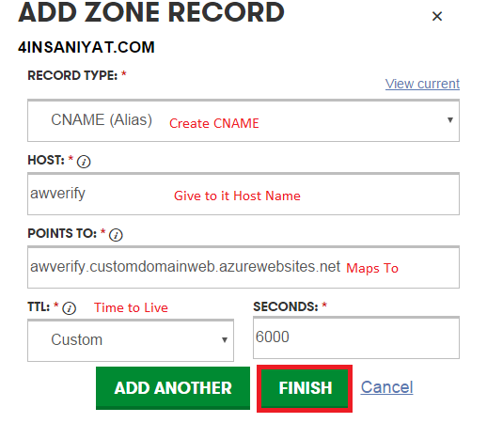

An *awverify* record is used to determine whether our own domain is going to attempt to use something means CNAME record that maps from *awverify.customdomainweb.Azurewebsites.net* to *awverify*.

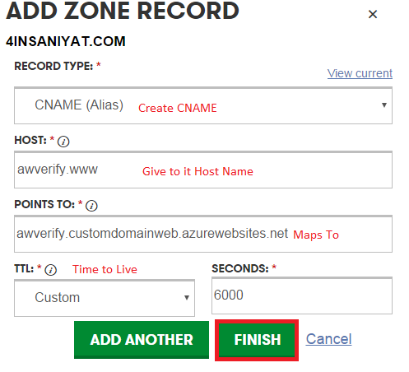

40

So here in the following screenshot put your domain name, it will be mark as green, means you have completed custom domain name.

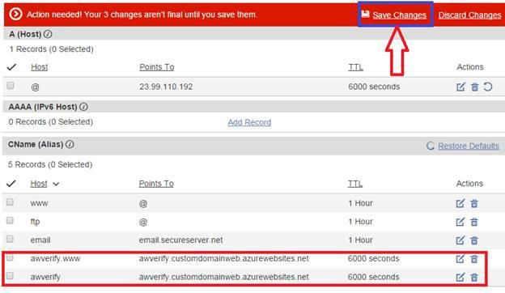

Click on to save changes to save all the changes.

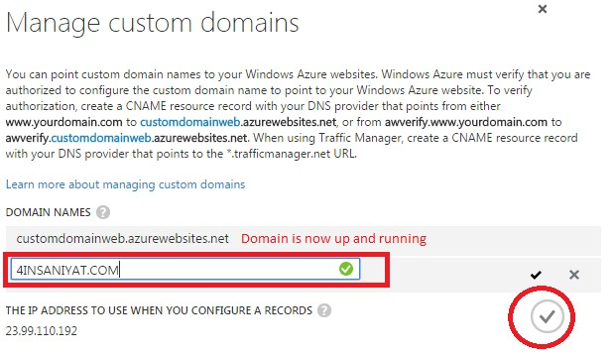

Just Click on button which is marked in circle and enjoy your website live on Azure with the domain name you want.

# Virtual Machine in Microsoft Azure Step by Step



41

You can create a virtual machine in [Azure](http://www.c-sharpcorner.com/technologies/azure) using one of the following methods:

* Use **Quick Create** when you need only one virtual machine for your solution, or when you need to connect it to a virtual network.
* Use **From Gallery** when you need a solution that requires multiple virtual machines or a virtual machine with advanced settings.
* A virtual machine is a server in the cloud that you can control and manage. After you create a virtual machine in Azure, you can stop and restart it whenever you need to.
* When you create a virtual machine, it is automatically started for you. You’ll know when a virtual machine is running because its status is Running. You can stop and restart a virtual machine at any time.
* Before you stop a virtual machine, you should make sure that applications running on the virtual machine are shut down appropriately. The applications that are running on a virtual machine are automatically shut down when the virtual machine is stopped.
* To stop a virtual machine, click its name, and then click Shutdown. When you stop the virtual machine, it shuts down just as your server in your office shuts down when you stop it. While the virtual machine is shutting down, its status is stopping. When the virtual machine is stopped, its status is stopped. If you set up load balancing for your cloud service, you should consider how stopping the virtual machine will affect your application.
* When a virtual machine is running and you want to restart it, click its name, and then click Restart. While the virtual machine is restarting, its status is Restarting. When the virtual machine is ready for you to use, its status is Running.

42

**Step 2:** By login in to Microsoft Azure, select "**NEW**‖ at the bottom of the window.

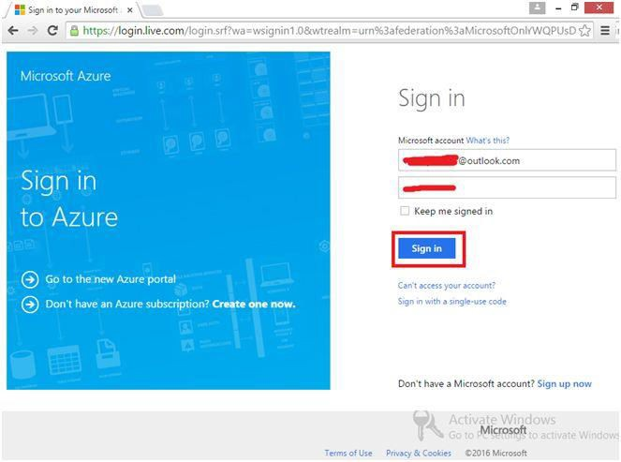

**Step 1:** Login to Microsoft Azure.

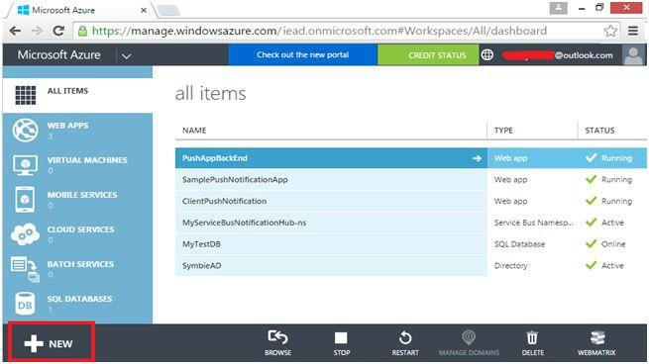

43

You will see the following figure,

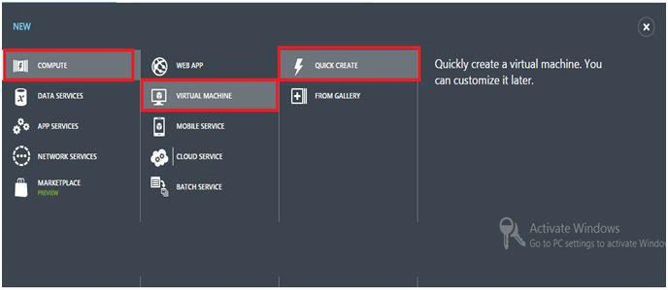

**Step 3:** Under "**COMPUTE**‖, select "**Virtual Machine**‖ and select "**Quick Create**‖.

Here, I am going to create **Quick Create** when we need only one virtual machine for our solution.

**DNS:** The DNS name must contain between 3 and 15 characters. The name can contain only letters, numbers, and hyphens. The name must start with a letter and must end with a letter or a number.

**Image:** Choose an Operating System image from the drop down menu; here I want to show "**Windows Server 2012 R2 Datacenter.**"

44

**Size:** In size, you can give a size to your virtual machine from different sizes in the dropdown menu.

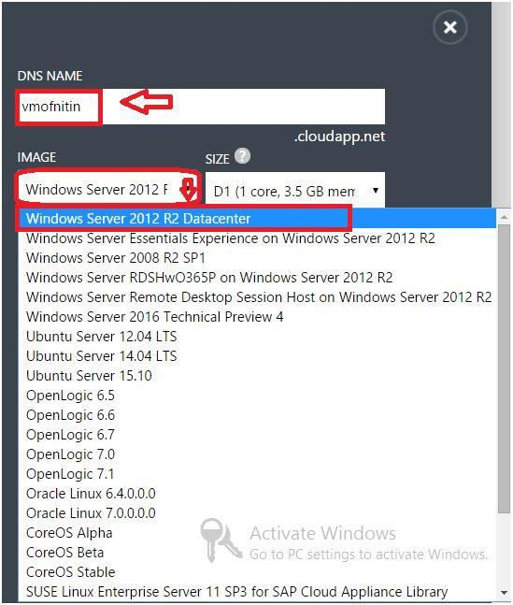

45

**User Name:** User Name is mandatory for the VM, it would be used at the time of credentials. Here I gave "*pandit.*‖

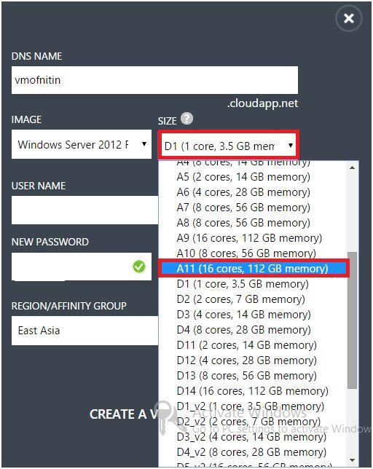

**Password:** Give the password for logging in to the virtual machine.

**Region:** I’m from India, so I am going to select "**East Asia.**‖

Hit on check mark to create a virtual machine (shown in the rectangle).

46

After the creation of the virtual machine, we need to connect it where we can access it remotely. Select your virtual machine and click on "**Connect**‖ button.

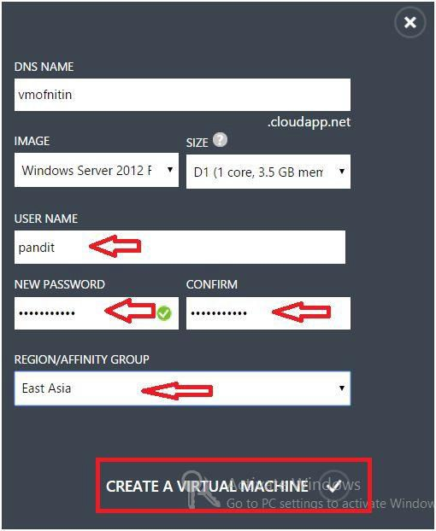

A file with extension "**.rdp**‖ will be downloaded.

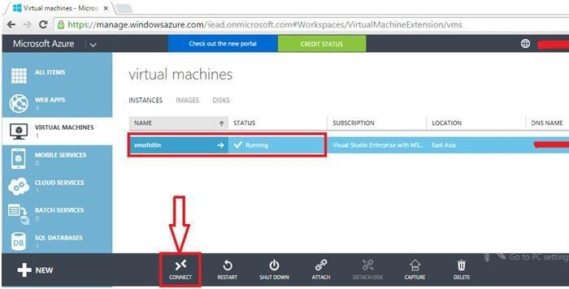

47

Go to the downloaded RDP file and open it. Remote Desktop is enabled by default. Click on "**Connect**‖ button.

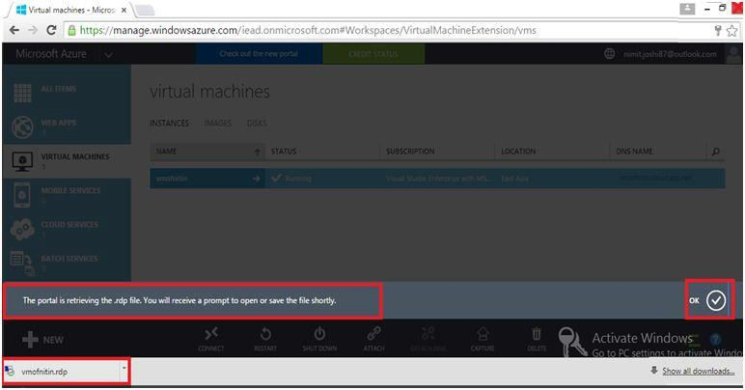

It will display a message for the file.

Open the downloaded RDP file.

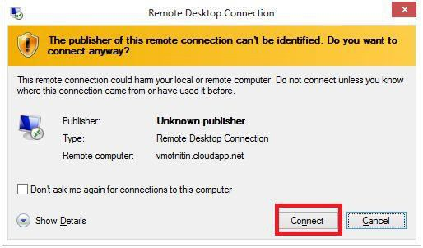

After clicking on connect button it will start the remote connection.

48

Now, we need to complete security by entering credentials, user name and password which we setup during creation of the virtual machine.

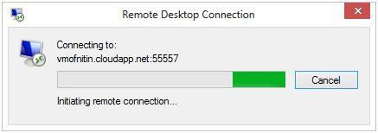

Click on "**OK**‖ button.

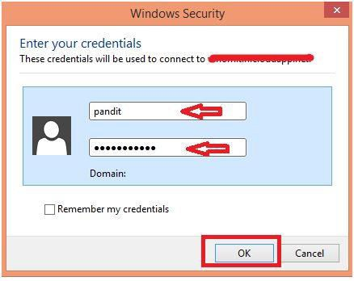

Click on "**Yes**‖ button.

49

After entering your credentials, click on "**yes**" and you will be connected with your Virtual Machine.

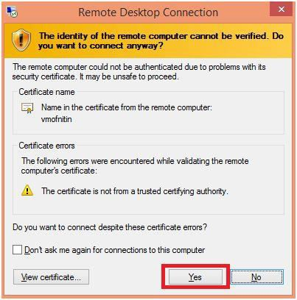

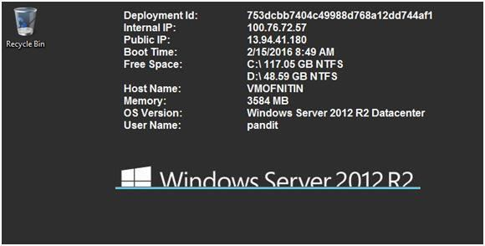

Here is the **Dashboard**.

50

Make sure you don't forget to shut down your VM after completing your work. You can shut down it from **shutdown** option as in the following:

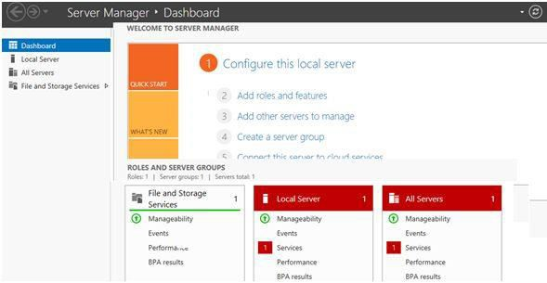

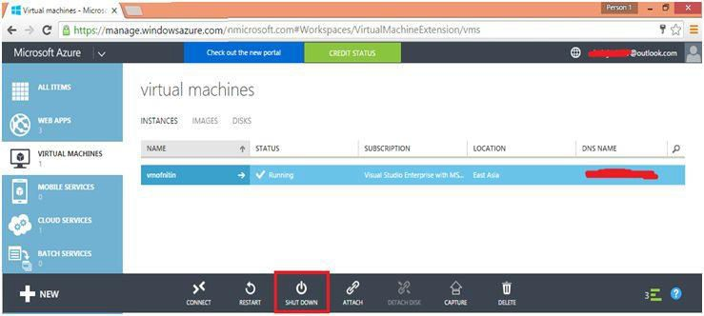

51

Now, here I am going to create a virtual machine using the **"FROM GALLERY"** option. This is for when you need a solution that requires multiple virtual machines or a virtual machine with advanced settings.



**Creating a Virtual Disk Virtual Machine in Microsoft**

**Azure Step by Step**

In the previous chapter we discussed how we can [create a virtual machine from ―Quick Create‖](http://www.c-sharpcorner.com/article/virtual-machine-in-windows-azure-step-by-step-part-one/)

option in part one of the series.

Select ―**COMPUTE**‖ and ―**VIRTUAL MACHINE**‖ and select ―**FROM GALLERY**".

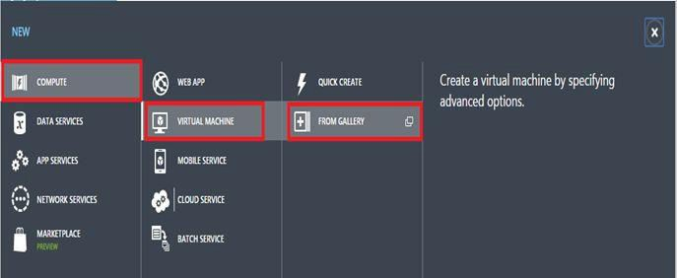

[Azure](http://www.c-sharpcorner.com/technologies/azure) gallery provides Windows + Linux and their entire version. Select your desired operating system image and click next. I have selected **Windows Server 2012 R2 Datacenter**.

So select an image, whatever you want to show with your virtual machine.

Here, I’m going to select ―**Windows Server 2012 R2 Datacenter**‖.

52

Give the Virtual Machine name, Tier, size, username and password. Hit on Next (Shown in Rectangle at the bottom of the page).

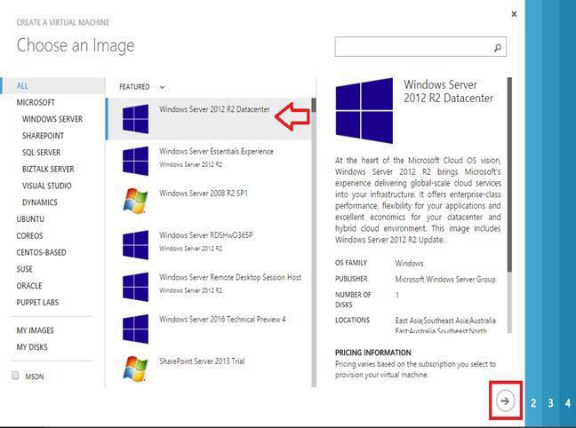

53

Here next is configuration window; all is set by default, so click next.

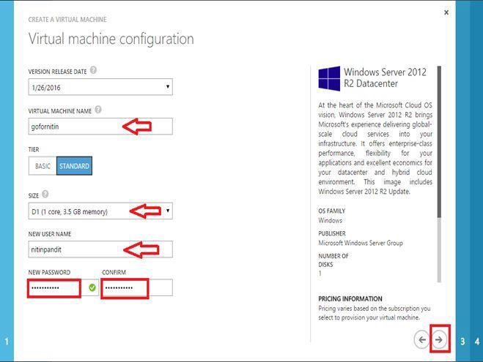

54

You can see the following window, it will ask for configuration extensions and security extensions, so here all is set by default.

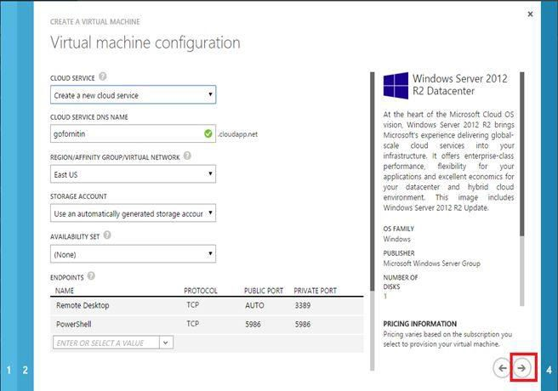

Click on to Next.

55

Here you can see, your virtual machine is creating, which is ―**gofornitin**‖.

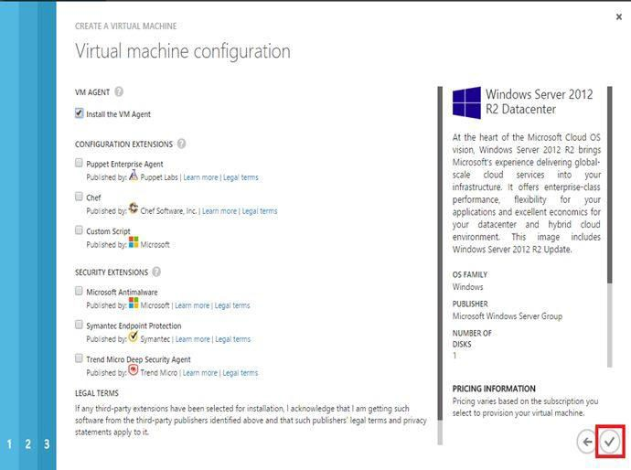

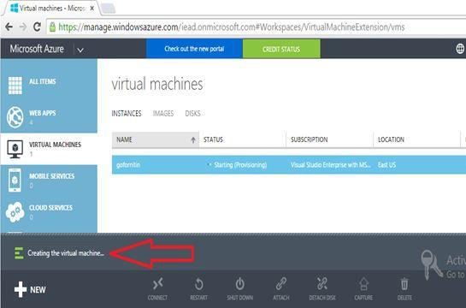

56

So, here you can see portal retrieving a file with .rdp extension. Click on file to open it.

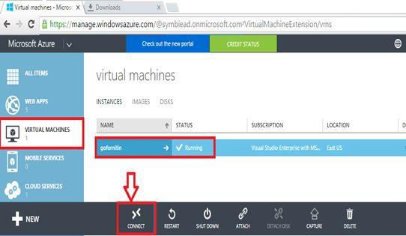

For using the virtual machine, click on ―**CONNECT**‖ button.

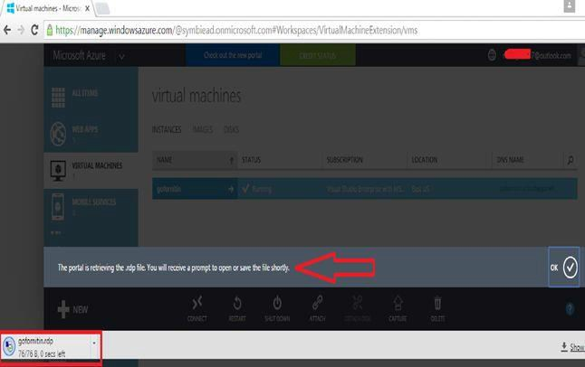

57

Enter your user name and password, my user name is ―*nitinpandit*‖. Click on ―**OK**‖ button.

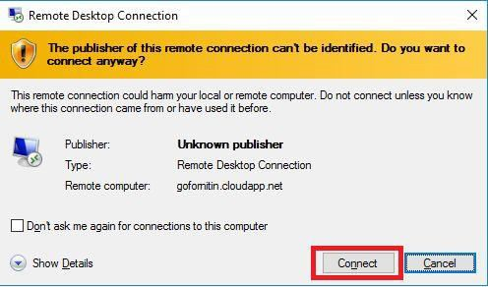

Click ―**Connect**‖ button.

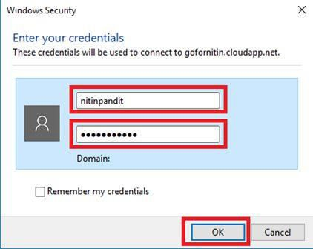

58

Click on ―**Yes**‖ button.

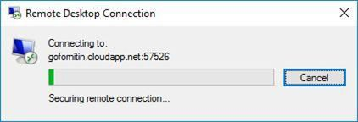

You can see I’m getting connecting to my virtual machine.

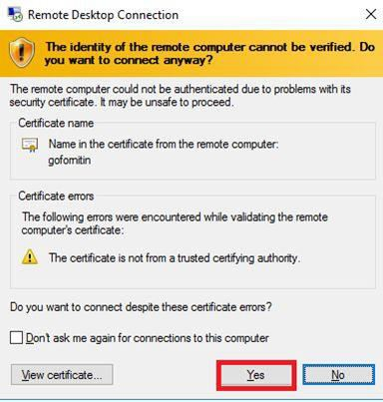

In the following screen shot, I’m successfully connected with my virtual machine; you can see

**Dashboard** of the **Server Manager**.

59

Go to the ―**All Servers**‖ and check the server name.

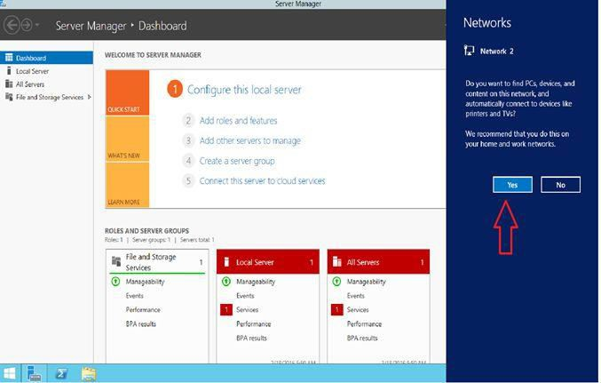

Click on to ―**All Servers**‖, you will find ―**gofornitin**‖ server is available there.

60

In the following screenshot, you can check your virtual machine’s overall details, where you can

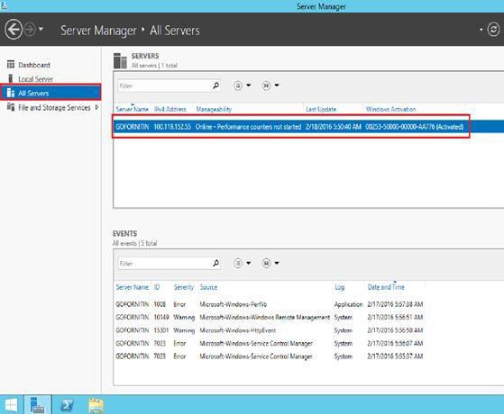

see free space, host name and other related information of Virtual Machine.

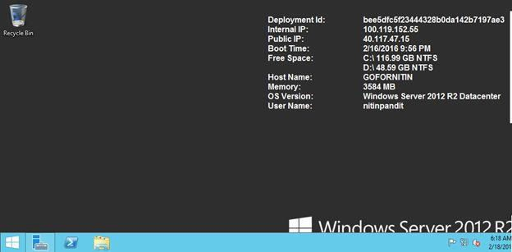

61

It will ask to fill in the details for the empty disk.

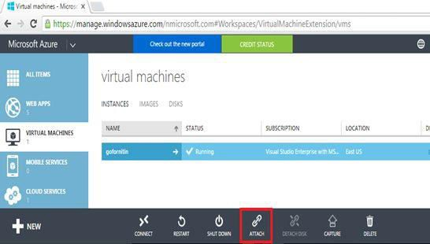

Now, I’m going to add extra space in machine and an extra disk drive on it.

For this, select your appropriate Virtual Machine and click on ―**ATTACH**‖ button.

It will take machine name (gofornitin), storage location, and file name by default. Give the size for disk which you want to be created; here I have given it 15GB. Click on the check button.

62

It may take some time to create a new empty virtual machine. Here you can see, our virtual machine is creating.

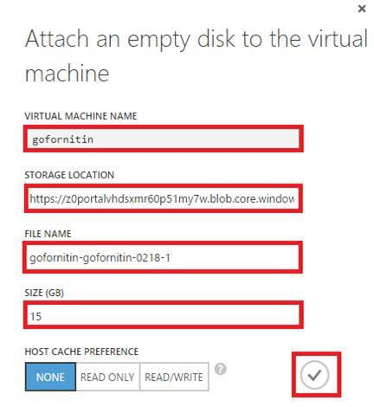

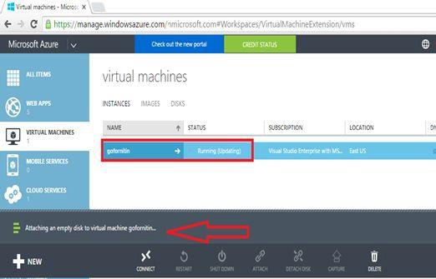

63

Follow the last process, click on to downloaded .rdp file.

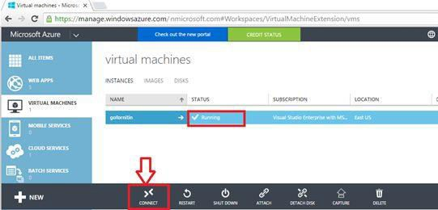

So now, your virtual machine is ready for use and is in running mode.

Click on ―**Connect**‖ button to retrieve the .rdp file.

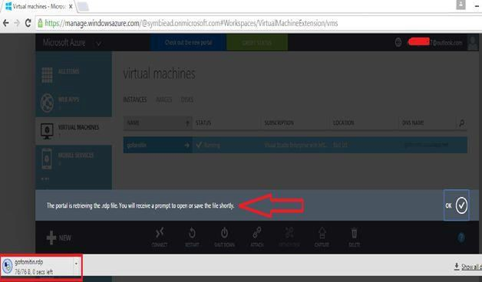

64

Click on to ―**Disks**‖ button and refresh the current page.

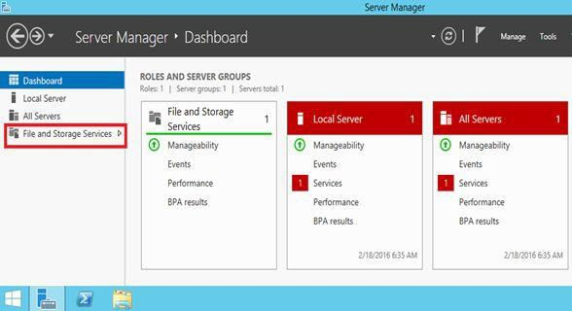

To check there is 15 GB disk in or not, simply go to the ―**File and Storage Services**‖.

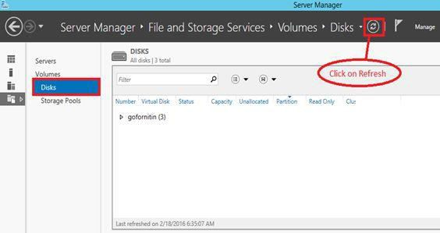

Click on to ―**gofornitin**‖ and you can see our 15 GB virtual disk successfully added.

65

Let’s check it to Disk Management.

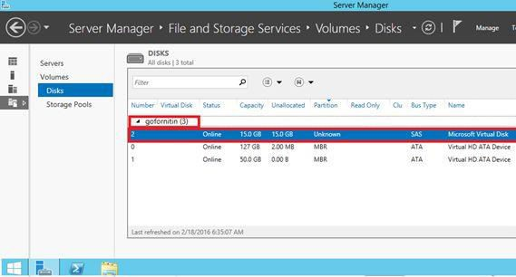

There is also 15GB virtual disk available, and status of disk is online.

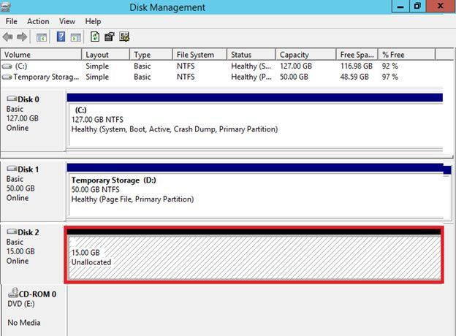

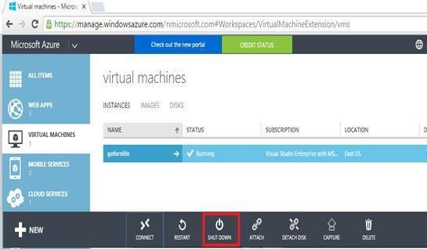

Make sure, click on ―**Shut Down**‖ button to shut your virtual machine.

66

67

## tool provided by Microsoft.



**Use of SQL Azure in Visual Studio 2015 Step By Step**

**Guide**

**In this we have to learn all about SQL Azure, it’s very simple to use and also a powerful**



Microsoft made a revolution in Cloud History by Microsoft Azure. Microsoft does a lot of changes in Azure day by day providing best possibility for every user or developer. In Azure, we have lot of support for database such as NoSQL, SQL Server and more. In Microsoft Azure we can use SQL database by the following two ways:

## 1. Microsoft SQL Server

We can use Microsoft SQL server in Microsoft Azure Virtual Machines (Azure VM) which is used as **IAAS (Infrastructure as a Service)** where we have full access by RDA (Remote Desktop Access) on this VM where we can use any Microsoft SQL Server.

2. **SQL Azure**

Sql Azure in the second option to use Sql Database on cloud which behaves like **PAAS** and it’s very simple or easy to access by web portal of Microsoft Azure or in Visual Studio Azure SDK.

68

## What is SQL Azure Database?

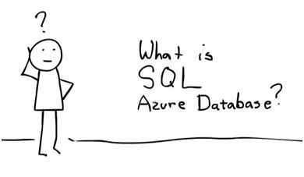

3.

In short, SQL Azure database is simply a way to get connected in Cloud Services where we can store our database into Cloud. Microsoft SQL Services and Microsoft SQL Data Services are now known as Microsoft SQL Azure and SQL Azure Database. Microsoft Azure is the best way to use **PAAS (Platform as a Service)** where we can host multiple databases on the same Account.

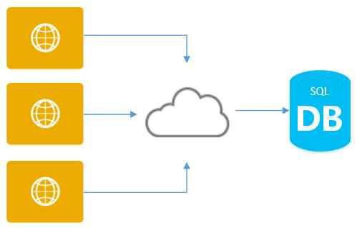

Microsoft SQL Azure has the same feature of SQL Server, i.e. high availability, scalability and security in the core.



69

## Built-in Automatic Backup in Microsoft Azure SQL Database

Microsoft Azure SQL Database have a best feature, it automatically creates backups of every active database. Every hour a backup is taken and geo-replicated to enable the 1 hour recovery point objective (RPO) for Geo-Restore. Additionally, transaction log backups are taken every 5 minutes to enable Point in Time Restore.

## Backup Storage

As per MSDN:

"*Backup storage is the storage associated with your automated database backups that are used for Point in Time Restore and Geo-Restore. Azure SQL Database provides up to 200% of your maximum provisioned database storage of backup storage at no additional cost. For example, if you have a database in the Standard service tier with a provisioned size of 250 GB, you will be provided with 500 GB of backup storage at no additional charge. If your database exceeds the provided backup storage, you can choose to reduce the retention period by contacting Azure Support or pay for the extra backup storage billed at standard Read-Access Geographically Redundant Storage (RA-GRS) rate. For more information on RA-GRS billing, see Storage Pricing Details."*

## Now let’s see how to create SQL Azure Step by Step

In your Azure Account Portal you have a link to use your Sql Databases on SQL Azure, so go to the [Link.](http://manage.windowsazure.com/)

Login now and go to portal Link where you can see Sql Database,

70

If you click on this section, you’ll find all the already created databases and will get the link to go to servers, every database exist in any physical server, but for SQL Azure we don’t need any hardware or software to use that because it’s a **PAAS** on Cloud Services provided by Microsoft Azure but still you have to create a server where you want to use your datacenter or replica of your database. So first we want to create a server, now let’s see how to create Data Server, but one thing you should remember, we don’t have RDA (Remote Desktop Access) permission on this server we can use this database in our Visual Studio or in our Microsoft SQL Server Management Studio so that we can create table and can execute our .sql script file for database management. So finally in this article we’ll learn all the things step by step which is divided into the following seven parts:

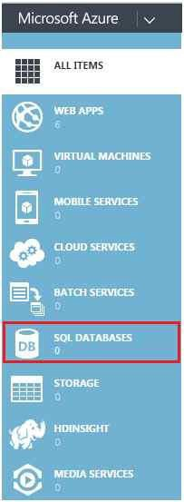

1. How to Create Servers in Microsoft Azure.
2. How to Configure Server for Client access by IP Addresses.
3. How to create Database on specified Server.
4. How to get the connection strings.
5. How to Use SQL Azure in Visual Studio.
6. How to Use SQL Azure Table for CRUD Operations in ADO.Net.
7. How to Use SQL Azure Table for CRUD Operations by Entity Framework.

So I hope you’ll enjoy this, now it’s time to do everything by yourself, firstly login into your



71

Microsoft Azure Account.

**Now let’s see How to Create Servers in Microsoft Azure**

We need a server first to create any Sql DB to host on SQL Azure, so click on SQL Databases link in main menu and get the entire database already created and on the top there is a link. Servers find that link as I have shown in the following image:

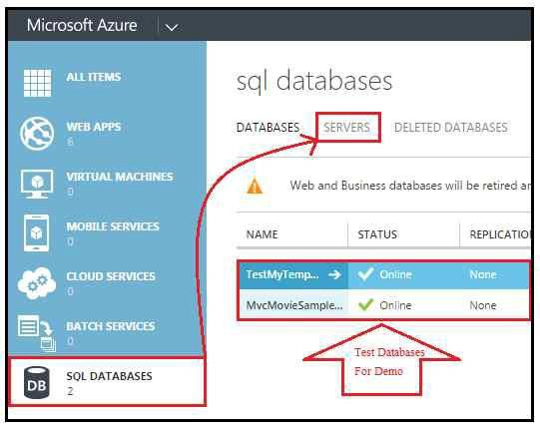

After clicking on Servers, you’ll get the entire server which already running on the cloud service. Now the next step is find the button Add to add or create a new Server as in the following image.

72

Now fill this form to set all the necessary details for a server like Login Name, Password, Confirm Password and region for selection of Datacenter and after filling all the information press enter to submit all the details and then that will create a server by a logical server name. It will be a combination of alphabetic and numeric digits which we have to use to create a database.

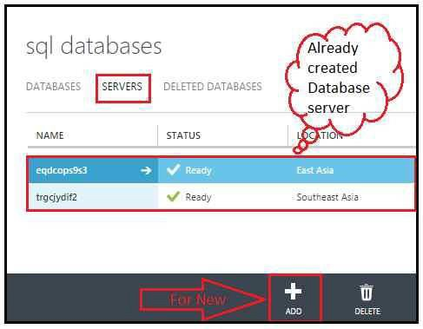

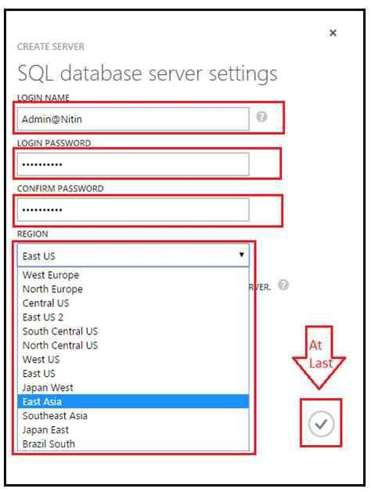

73

After that now server is ready to use with a logical name but if you use this server to host your database, you don’t have permission to use on any client IP, so we need to configure this server for specified client IP addresses and go to the next step.

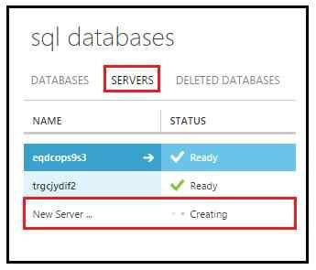

After submitting all the information about our server it will take a few seconds to create it.

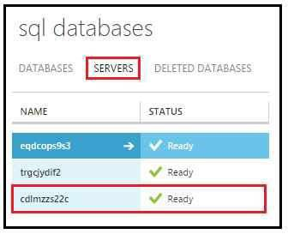

74

In this section there is an option to add details for every client where you need to login this server. Add all IP addresses with the rule name and you want to access the same system, so there is directly a link to add current system in the list as in the following image.

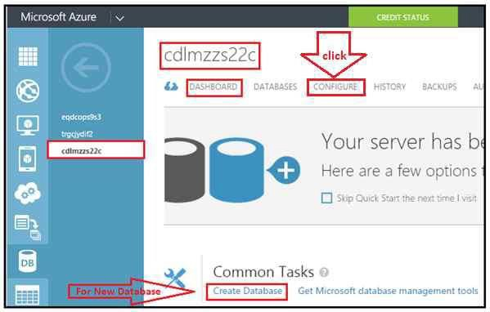

**Now let’s see How to Configure Server for Client access by IP Addresses-**

Every server is a must be configure for every client system IP address, so let’s see, first click on the server logical name to open the server dashboard or configuration sections. Now open the configuration section, so click as per the following screenshot:

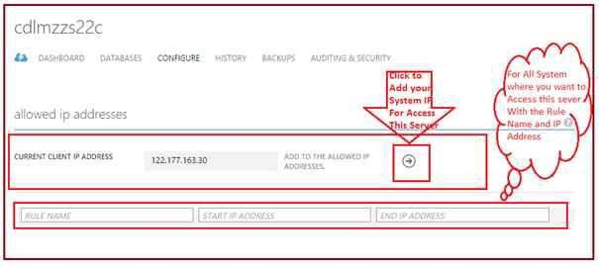

75

At last, just save the setting which have changed before leaving this section or creating new database.

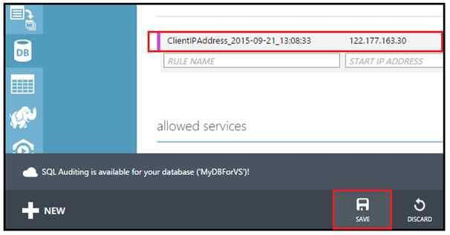

Now your system and all those systems are able to get connected with this server and those IP address is added in the list.

## Now let’s see How to create Database on specified Server

Now the time is to create a SQL Azure Database on cloud as PAAS, so now find the + New Button on the left side bottom in your Web portal of Azure and click that.

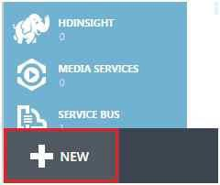

76

If you select Quick create, you have to enter only the name of database and select the server by

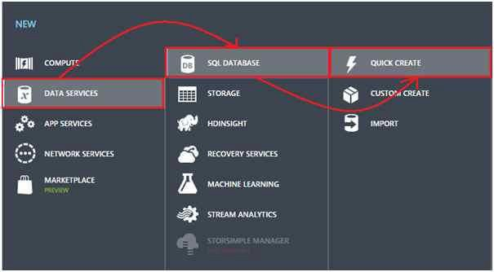

Now go to Data Services, then SQL Databases and Quick Create or Custom Create.

the logical name of the server and click ―**Create SQL Database**‖ button.

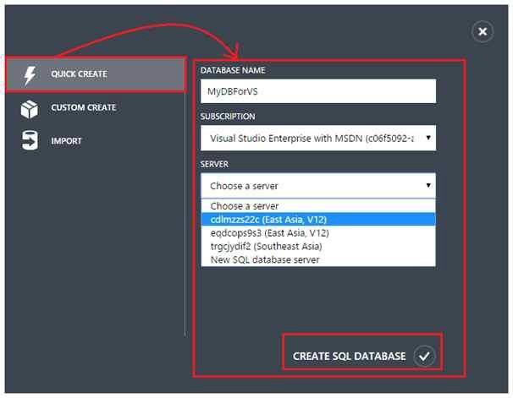

77

After submitting all the details it takes few seconds to be ready for use and you can see the progress in the Progress bar.

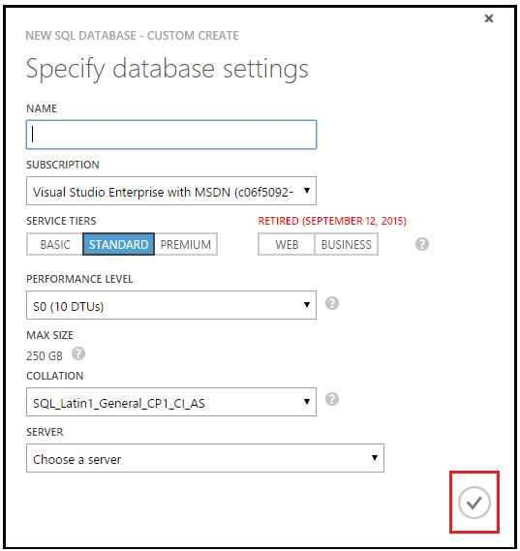

If you select Custom Create, you have many options to fill or select Database Name, Subscription Type, Max Size and Server Name and then click ok.



Now your server is ready to use from your Visual Studio or SQL Server Management Studio.

78

## Now let’s see How to get connection Strings

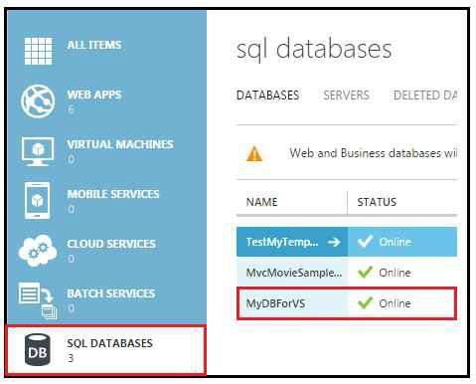

Now the most important part is if you want to connect this database to store your data as per need in any Application by any framework or technologies like in php or java and more. So the first thing which we need is Connections String to connect, so let’s see how to get the connection string. Firstly, go to the Dashboard of the database.

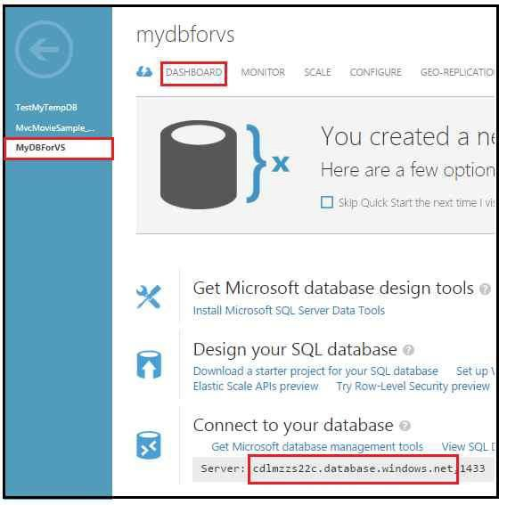

79

Now you will see the window of connection string where we have all maximum connection string for every developer for every technology **ADO.Net, JDBC, PHP** and **ODBC,** so you can use it anywhere just add password in the connection string.

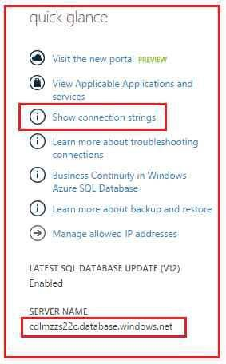

In the Dashboard section there is an option in quick glance ―**Show Connection Strings**‖ and below that there is the server name by which you have to connect in Visual Studio Server Explorer. So click on the link of Connection Strings.

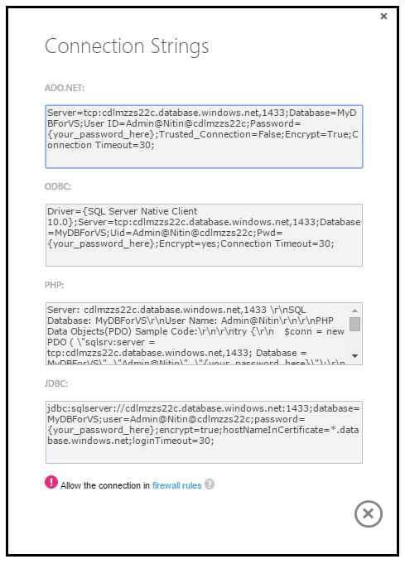

80

81

Open Server Explorer to connect SQL Azure Database.



**Now let’s see How to Use SQL Azure in Visual Studio**

Now let’s see how to use SQL DB to your Visual Studio Server Explorer or may be in SQL

Server Management Studio. Open your visual studio first.

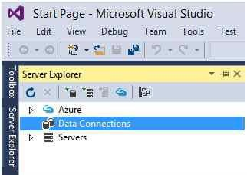

Right click on *Data Connections* and add Connections, then there is a window, fill all the details and copy the Server Name from Database Dashboard in Azure web portal and paste in this window. Now enter the user name which was entered by you at the time of server creation like

―**ServerUserLoginName@ServerLogicalName**‖ and password. Select your database name from the list and click ok or Test Connection button if you want to check your connection is valid or not.

82

This is the same process for Microsoft SQL Server Management Studio, the people who don’t

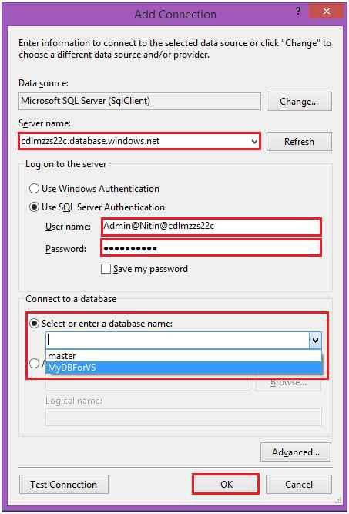

have Visual Studio like DBA, they can use there .sql script file over there.

83

So let’s see with Visual Studio I connect my Azure Database server in the Server Explorer.

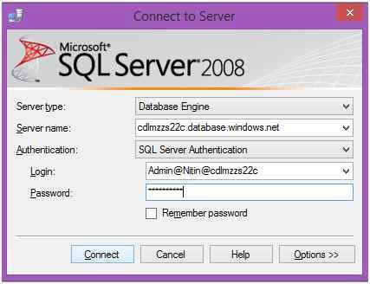

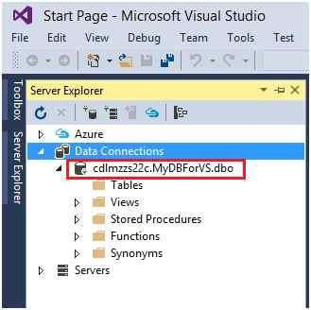

84

If you want to create table by query, select New Query or if I want to add by wizard, click on Add new Table and then you get a window on your screen where you have to add columns and add constraint if required. After writing your query or adding columns, just click on Update Button. It will confirm and save the schema.

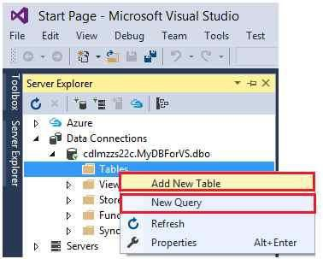

Now if you want to add a new table right clicks on Tables and find two options Add new Table and New Query. Select any one.

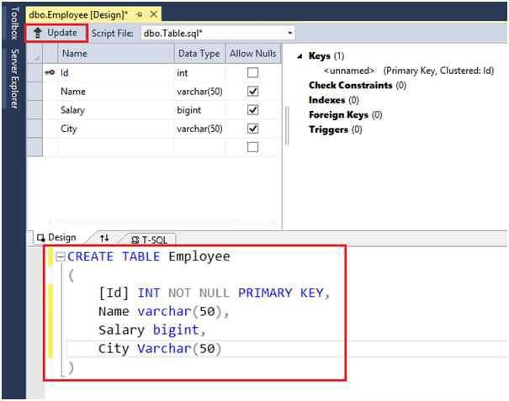

85

You can see the update of progress in the Data Tools Operations.

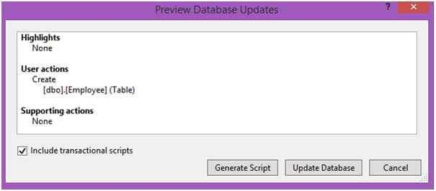

In this window we have two options: Click Generate Script if you want to create Script file and it will save automatically in the solution or any specified address. The second option is to Update Database if you want to update all schemas without saving query file, it will update SQL Azure Database with new Schema.

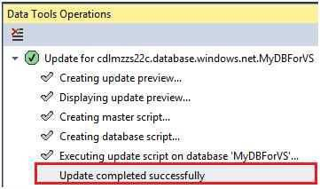

Now open server explorer and refresh connection, now you can see your table in Tables options.

86

Now use this table anywhere with the connection string that we get by our Microsoft Azure portal.

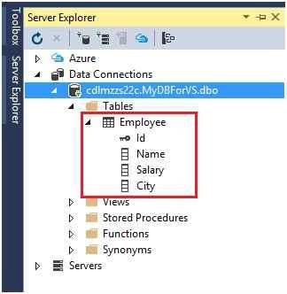

## Now let’s see How to Use SQL Azure Table for CRUD Operations in ADO.NET-

If you want to connect this use your SQL Azure table in any application such as Windows Form, WPF Application, Console Application or any web application. This is the same process so I am using a web application project in Visual Studio. Open Visual Studio, File, New Project, then select Web and click ASP.NET Empty Web Application.

Give a name and location and press OK.

87

Now I have an empty Web Application Solution, so add any page to show the data or use CRUD operations in SQL Azure Table. I just added a page default.aspx to do that.

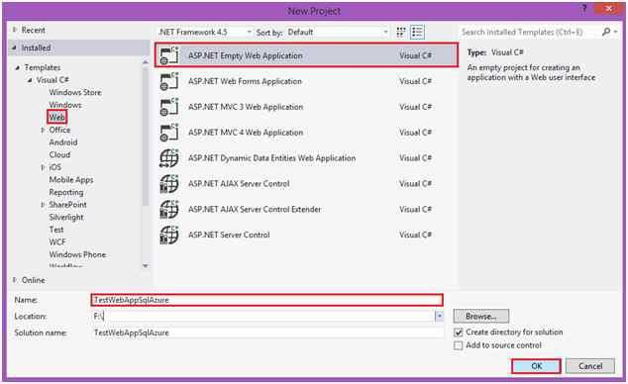

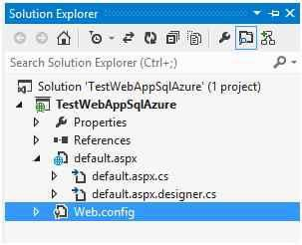

88

Use some control like **GridView** and other control like **TextBox** and Button event.

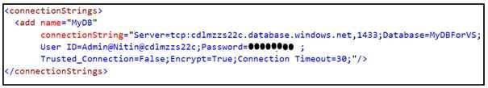

Now add a new Connection String into Connections String Sections in your web.config, copy connection string from Azure Web portal and paste with password in Web.config like the following image:

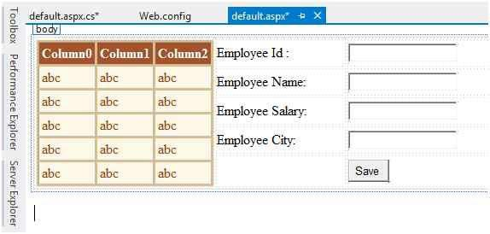

I just use a simple code of ADO.NET with SqlClient provider, on the button I run command and if it runs successfully, I called a function where I bind the grid from my Azure SQL Client.

**Code:**

**using** System.Data;

**using** System.Data.SqlClient;

**using** System.Configuration;

**public void** BindGrid()

{

SqlDataAdapter da = **new** SqlDataAdapter("Select * from Employee", ConfigurationManager

.ConnectionStrings["MyDB"].ConnectionString);

DataSet ds = **new** DataSet(); da.Fill(ds);



89

GridView1.DataSource = ds.Tables[0]; GridView1.DataBind();

}

**public int** RunCommand(**string** Query)

{

SqlConnection con = **new** SqlConnection(ConfigurationManager

.ConnectionStrings["MyDB"].ConnectionString); SqlCommand com = **new** SqlCommand(Query,con); con.Open();

**int** res=com.ExecuteNonQuery(); con.Close();

**return** res;

}

**protected void** Button1_Click(**object** sender, EventArgs e)

{

**string** qry = "Insert into Employee Values ('" + TextBox1.Text + "','"

+ TextBox2.Text + "','" + TextBox3.Text + "','" + TextBox4.Text + "')";

**if** (RunCommand(qry) > 0)

{

BindGrid();

}

}

Here's the output

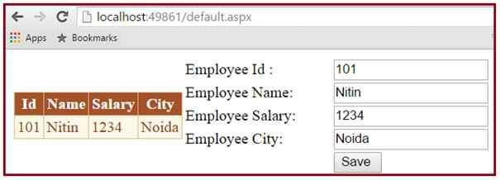



**Now let’s see How to Use SQL Azure Table for CRUD Operations by Entity Framework**

**Database First approach**

In the last point of this article we’ll learn how to use SQL Azure Table in your Application with

Entity Framework code first approach. So let’s start, just create a basic empty application as the previous point.

90

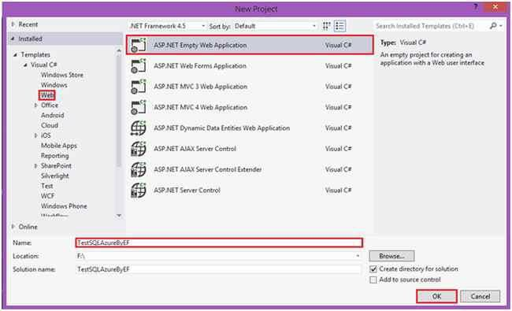

In Empty Solution, firstly, add an ADO.NET Entity Data Model.

91

Give a name to your model and click OK.

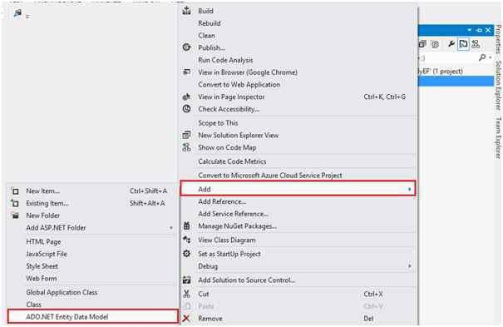

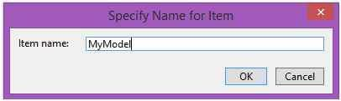

In this window, select Generate from database and click next.

92

Now make a connection with SQL Azure Data server to ADO.NET Entity Model.

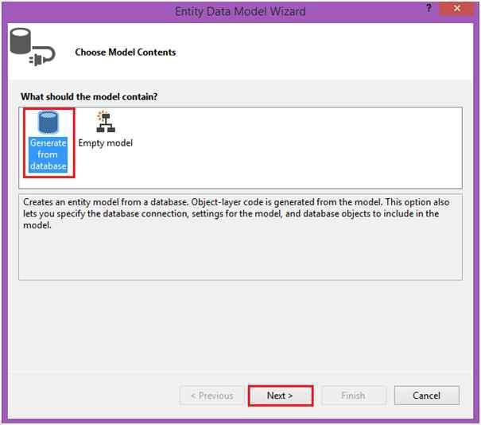

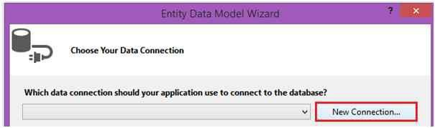

Enter all the details as per the previous point where we discussed how to connect in Server Explorer.

93

Click Next if the Next Button is enabled and if not, select a Radio Button, which is ―*yes include the sensitive data to connection string*‖ and give a name to your Entity class name. Name it anything you want like I just gave a name **MyDB**. After that click on to next.



94

Now select how many tables you want, select them and press Finish Button.

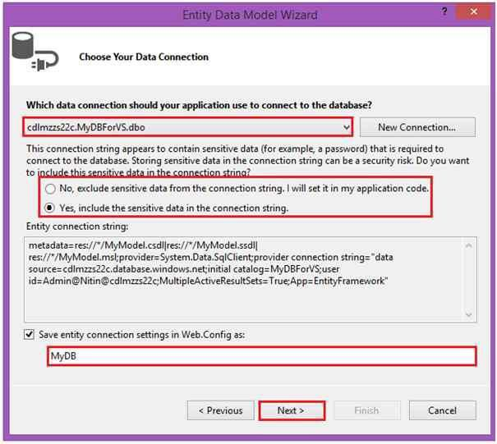

95

Now you’re Model and Entity File is ready to use.

